WRAPPED: A Short History of the Long Road

IN PRODUCTION:

Messiah

Directed by:

James McTeigue
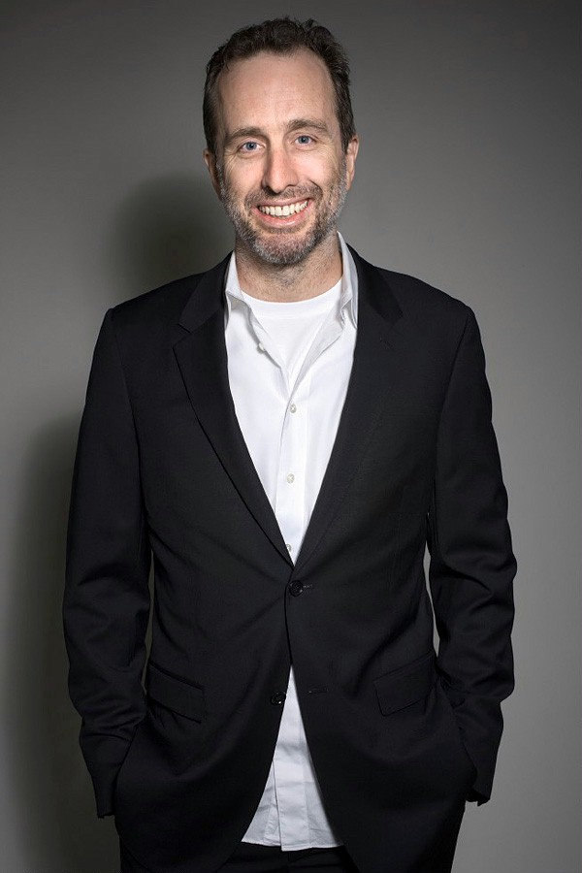

Executive Producers:
James McTeigue
Mark Burnett
Roma Downey
Andrew Deane

Starring:
Michelle Monagha

The Weird Place

Directed by:
Drew Saplin

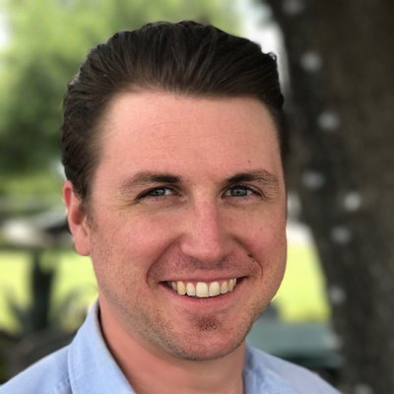

Starring:
Geoff Ramsey

The Divorce

Directed by and starring:
Lindsy Campbell

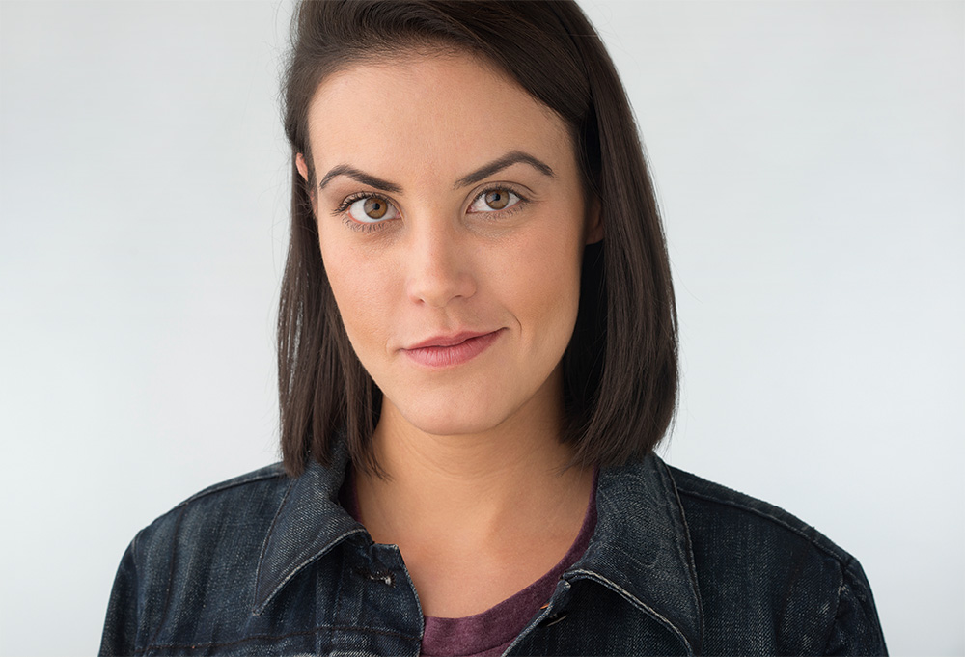

Starring:
Navid Negahban
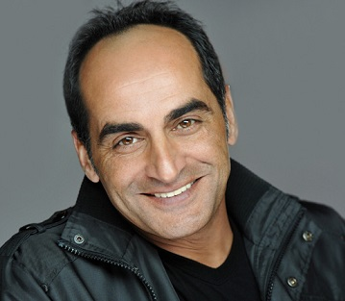

Laura Niemi

Julia Eringer
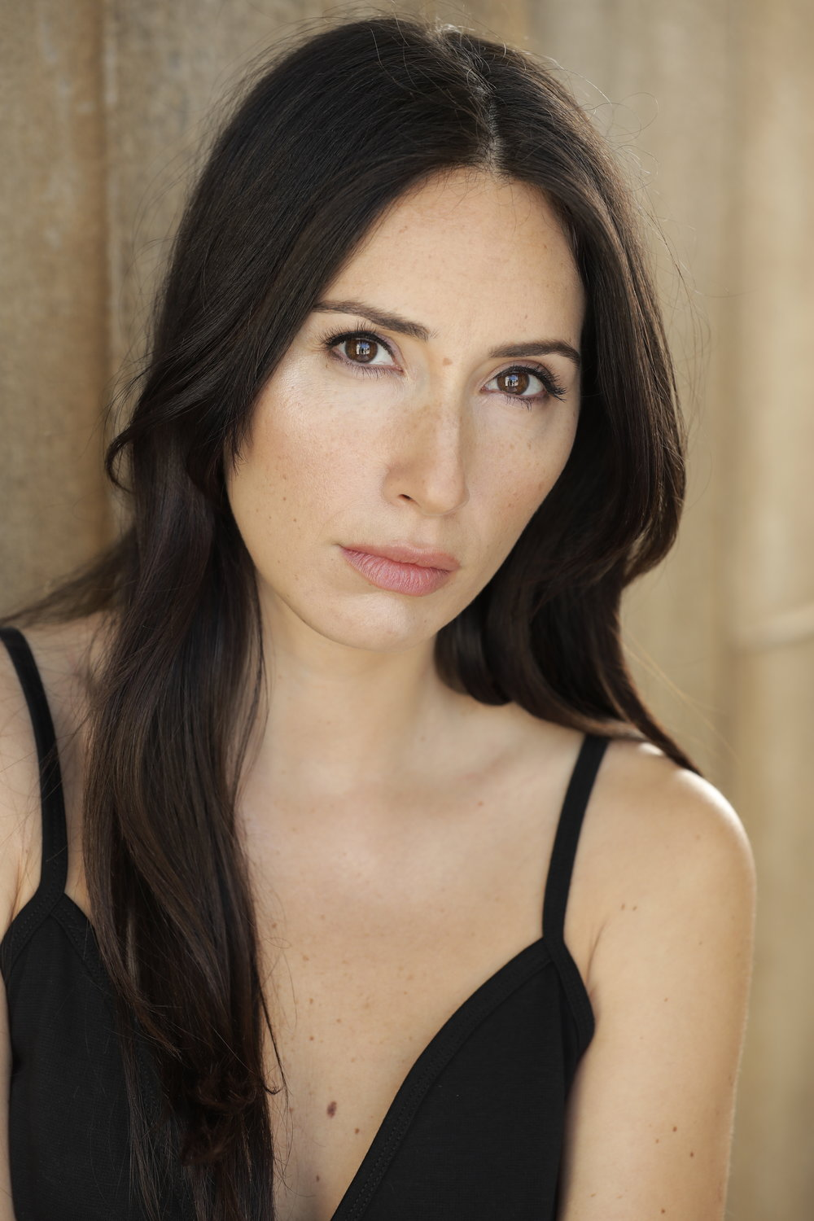

Jordan Olguin
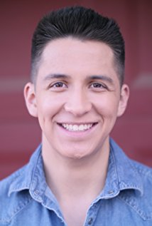

Ron Weisberg
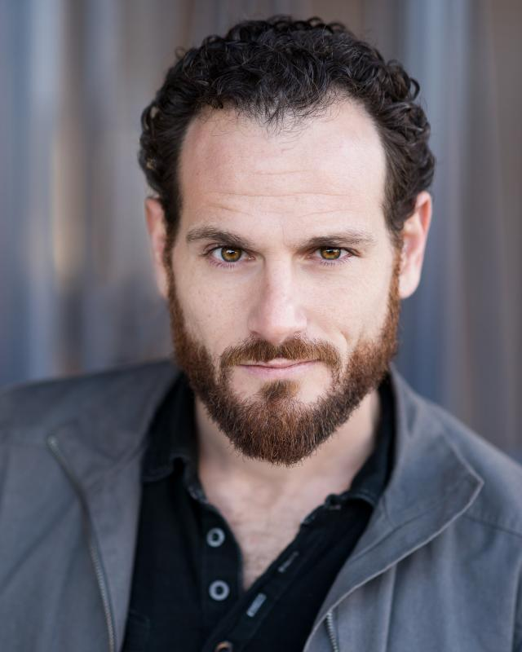

Chris Ranney
